14.39: The water is discharged at a rate of 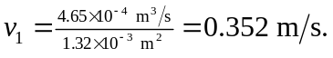 The pipe is given as horizonatal, so the speed at the constriction is 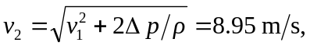 keeping an extra figure, so the cross-section are at the constriction is 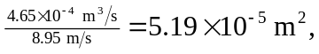 and the radius is 